CS210 Project

Justas Grimaila  
19340073  
2nd Year of Software Engineering through CS(MH601)

1.Overview of Game  
My game follows the simple premise of you being an on-ship A.I. on board a colonial ship heading to a distant planet. You have 25 weeks to get to the said planet, while also maintaining your ship’s hull integrity (Hull HP in game) and the amount of people on board. You can’t let these values drop, otherwise you fail your mission. These values can be altered by random events that happen week by week, which require the players direct input in order to make decisions to survive these events.  
  
 Some events will require you to trade Hull HP for the humans to survive. Others will need you to trade lives to avoid damage. Some events will help you and some will be out to just utterly destroy you.  
Some events are also more difficult than others.   
  
 The game plan follows this general cycle:  
 New Week -> Event -> Choice -> Outcome -> New Week.  
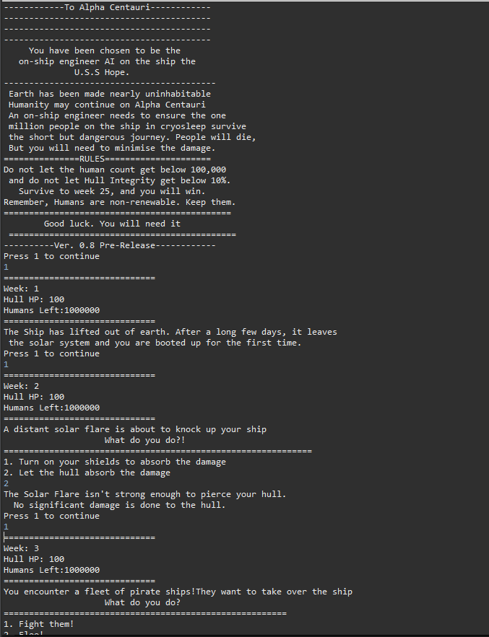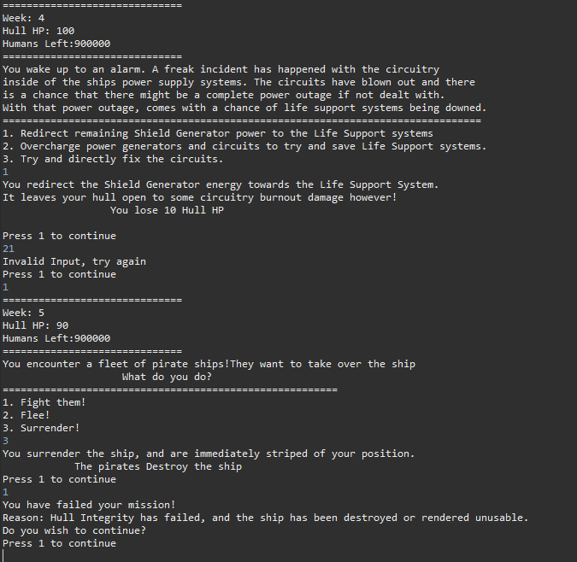  
  
Above: Examples of the game running in the Eclipse-IDE Console.  
  
2.How to play  
The game makes use of the players decisions to progress. It is a multiple choice game, so therefore, the player must input an integer depending on the event prompted in the console. For example, lets say you get two decisions. You will have to press either 1,2 or occasionally 3 in order to progress and make a choice.   
The game will take your input, and will go down the path of the number you chose. The event will play out, and depending on your choice, you will either succeed, fail or nothing will happen. Each event doesn't exactly play out the same too, so be careful!  
 Your choices have consequences in the form of affecting your Hull HP or Human Count, which are your basic resources for survival for not only your journey, but also the colonization process.  
  
 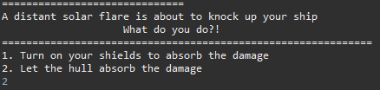  
 An example of an event, along with the choices you are given.  
  
  
 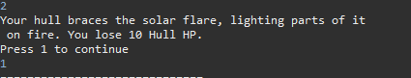  
An example of an event outcome, as you can see, 2 was chosen, but   
 by chance, the event failed, losing the player some Hull HP.  
  
The week ends after the event is done, and once you reach week 25, the game ends. The game can also end if the Ship falls below 20 HP or if the human count falls below 100,000.  
  
  
3.Code Structure  
The code written for this game is mainly composed of 5 methods.  
->A Main Method that acts as a Introductory/Main Menu of sorts.  
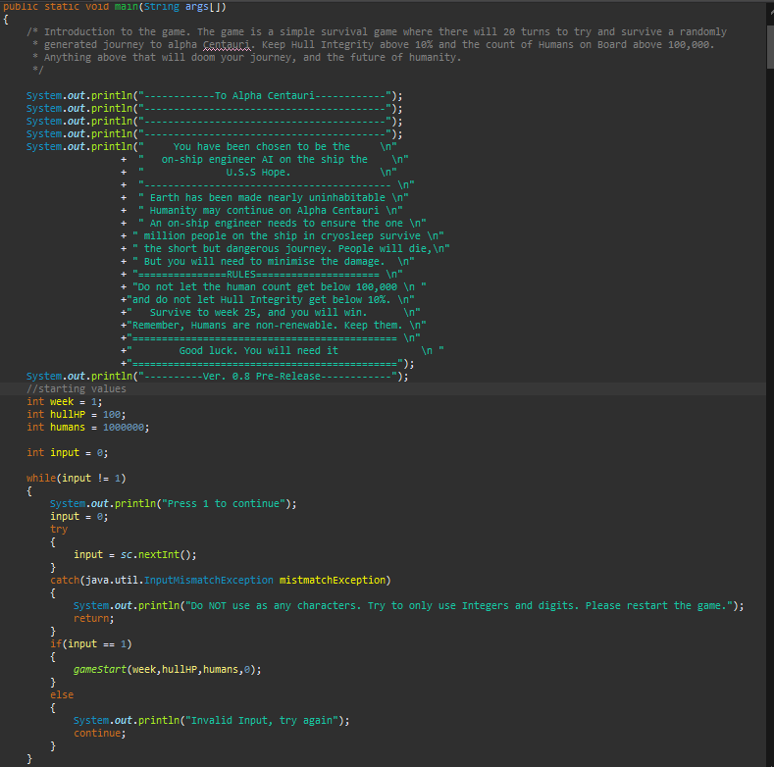  
->A recursive game logic method which keeps track of all the values  
 and all the random generation for the events in the game.  
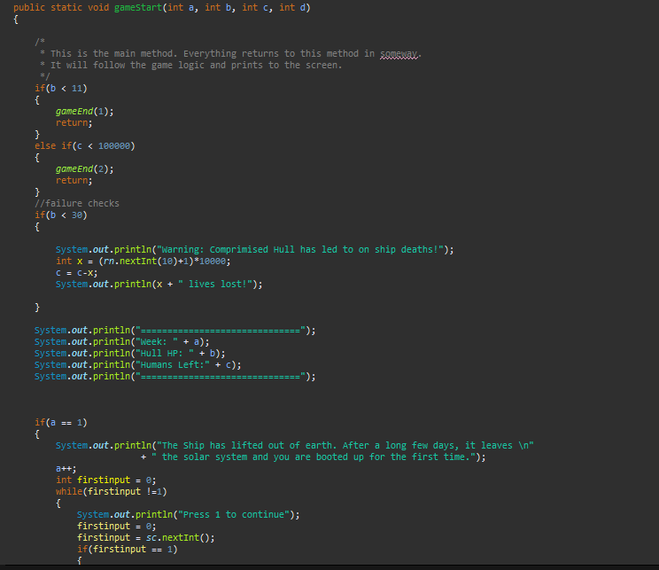  
Above: The general information prints at the beginning of each week, along side some code that.   
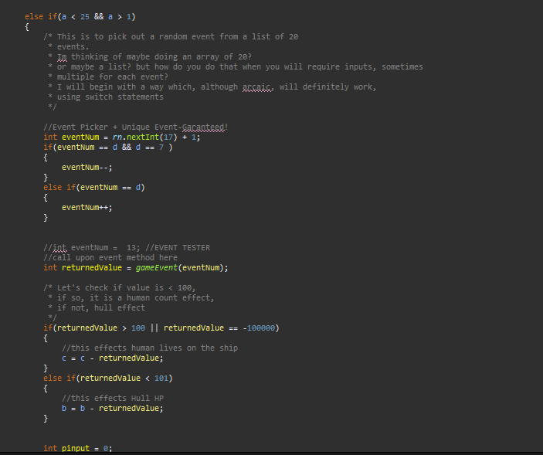  
The number generators and value updating code.